Holy Trinity Directory  Van Hogendorpstraat 26,  3581 KE Utrecht  www.holytrinityutrecht.nl  The Bishop of Gibraltar  Robert Innes (+44 20 7898 1160)  Chaplain  David Phillips (06 124 104 31)  revdgphillips@hotmail.com  Wardens:  Kit de Bolster  warden@holytrinityutrecht.nl  Adrian Los (Acting Warden)  06 11 88 50 75 adrian_los@yahoo.com  Chaplaincy Administrator  David Vollmer-Laarman  (06 285 529 53)  office@holytrinityutrecht.nl  Coordinator of Student Ministry  Marten van den Toren  (06 456 222 58)  m.j.vandentoren94@gmail.com  Lay Pastoral Assistants  Harry Barrowclough harrybar@xs4all.nl  Danielle Los daniellelos@yahoo.com  Master of the Choir and Organist  Henk Korff (06 53 13 00 86)  Treasurer  Beth Houdijk: treasurer@holytrinityutrecht.nl  Council Secretary  Simon Urquhart: secretary@holytrinityutrecht.nl  Safeguarding Officer  Ineke Cornet (06 571 756 24)  safeguarding@holytrinityutrecht.nl  Sacristan  Frank Boneschanscher  (06 200 615 58)  Altar Guild  Maria Koppenol (0645494717) maria@allea.nl | TODAY:  Bring and Share Lunch after the service.  All are welcome to join!  Volunteers wanted for after the service! The church needs to be cleared of all its decorations. Could you please lend a hand?  30 December - 13 January  Holidays of our Chaplain David Phillips and his wife Danielle, who will be visiting Thailand. There will be no mid-week services in this time. Emergency Contact:  Dec 30-Jan 5 – Jos Strengholt (0641021346‬)‬  January 5-13 – Grant Crowe (0629972303‬)  NEXT WEEK  MONDAY:  6:00 pm Teen Group WWJD. For teenagers from 11 to 16. Contact Nathan Bunt if you are interested or if you are the parent of a teen: 0624686859 or ndbunt@hotmail.com.  WEDNESDAY  7.30 pm The Road to Maturity. (Mary Pytches) Final session of six. Starts with coffee and tea, finishing 9:30pm. More information: daniellelos@yahoo.com.  THURSDAY:  8:00 pm – 10:00 pm Choir practice at the parsonage. New singers are welcome! Contact the Choir Master Henk Korff.  FRIDAY:  6:00 pm Student Movie Night at the parsonage. you are very welcome to join us for food and discussion! More information: m.j.vandentoren94@gmail.com  HYMNS NEXT SUNDAY AT 10.30 am (Healing Service)  89 O worship the Lord in the beauty of holiness; 66 (vs. 2,3,4) Once in royal David's city; 545 O sing a song of Bethlehem; 595 The Son of God his glory hides; 86 (vs. 1,2,3,6) From the Eastern mountains [Tune 1: Evelyns]; 267 Thou, whose almighty word  Words: copyright © 2000-2006 Common Worship, The Archbishops’ Council, CCLI licence number 639346

Daily Bible Readings – Epiphany 1– January 6 to 11
 | Morning Prayer |  | Evening Prayer
Epiphany | Isaiah 60 | Luke 3:15-22 | Isaiah 61 | John 2:1-11
Tuesday | Hosea 5.8-6.6 | Matthew 6.1-18 | Hosea 8 | 1 Thessalonians 4.13-5.11
Wednesday | Hosea 9 | Matthew 6.19-end | Hosea 10 | 1 Thessalonians 5.12-end
Thursday | Hosea 11 | Matthew 7 | Hosea 12 | 2 Thessalonians 1
Friday | Hosea 13.1-14 | Matthew 8.1-17 | Hosea 14 | 2 Thessalonians 2
Saturday | Joel 1 | Matthew 8.18-end | Joel 2.1-14 | 2 Thessalonians 3

Welcome to Worship!

HOLY TRINITY
ANGLICAN CHURCH UTRECHT

The Eve of the Epiphany of our Lord
1030 January 5 AD 2020 All Age Worship
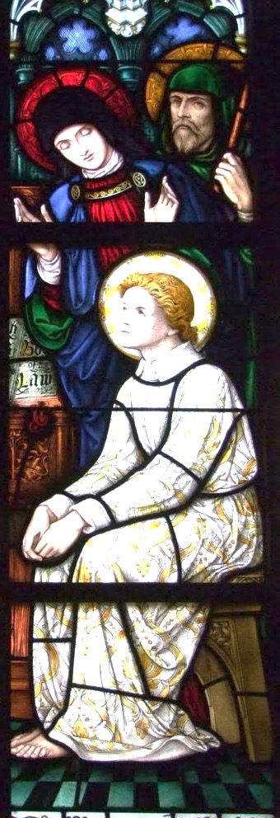
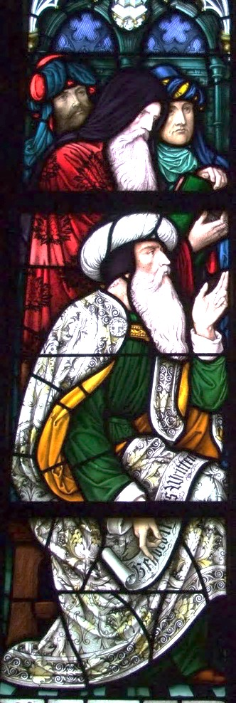

“‘And you, O Bethlehem, in the land of Judah,
are by no means least among the rulers of Judah;
for from you shall come a ruler
who will shepherd my people Israel.’”

Matthew 2:6

The Eve of the Epiphany of our Lord

We welcome the Revd Guy Diakiese Matumona, asistant curate at St John and St Phillip in The Hague, who will be leading our worship today.

Song:

Kom en vier nu feest  en laat je stem maar horen  want er is een Kind  in Bethlehem geboren  Het is de Zoon van God  wij willen Hem verhogen  Kom, zing met ons mee  glorie in de hoge  Glorie aan de grootste Koning  loof de Heer van het heelal  Hij is naar ons toegekomen  werd geboren in een stal  Die het licht is voor de mensen  en zijn vrede aan ons geeft | Hij geeft nieuwe hoop  en reden om te zingen  zal ons elke dag  en overal omringen  Hij is de Zoon van God  wij willen Hem verhogen  Kom zing met ons mee  glorie in de hoge  Kom laten wij aanbidden  kom laten wij aanbidden  kom laten wij aanbidden die Koning

Opening Words.

God in Christ has revealed his glory
Come let us worship

From the rising of the sun to its setting
The Lord’s name is greatly to be praised.

Give him praise, you servants of the Lord
O praise the name of the Lord.

We pray

All Almighty God, to whom all hearts are open, all desires known,
and from whom no secrets are hidden:
cleanse the thoughts of our hearts
by the inspiration of your Holy Spirit,
that we may perfectly love you,
and worthily magnify your holy name;
through Christ our Lord. Amen.

The Summary of the Law

The response to the Summary is: Amen. Lord, have mercy.

Brian will play music in the background as we reflect on our needs for the Lord’s mercy in our lives
- 10 -

May we who share Christ’s body live his risen life;
we who drink his cup bring life to others;
we whom the Spirit lights give light to the world.

Keep us firm in the hope you have set before us,
so we and all your children shall be free,
and the whole earth live to praise your name;
through Christ our Lord.

Amen.

The priest pronounces the Final Blessing

Notices After the notices we stand to sing the final song

Final Song: Beautiful One

Wonderful so wonderful is Your unfailing love  Your cross has spoken mercy over me  No eye has seen no ear has heard  No heart could fully know  How glorious how beautiful You are  Beautiful One I love  Beautiful One I adore  Beautiful One my soul must sing  Powerful so powerfulYour glory fills the skies  Your mighty works displayed for all to see  The beauty of Your majesty  awakes my heart to sing  How marvelous how wonderful You are | You opened my eyes to Your wonders anew  You captured my heart with this love  'Cause nothing on earth is as beautiful as You  My soul my soul must sing  My soul my soul must sing  My soul my soul must sing  Beautiful One

Go in peace to love and serve the Lord
All in the Name of Christ. Amen.

A warm welcome to you all!
Please join us for refreshments and fellowship after the service.
Today there is also a shared lunch, all are welcome to join.

Songs
Hope of the nations | Brian Doerksen Speak o Lord | Keith Getty | Stuart Townend How great Thou art | Stuart Wesley Keene Hine Create in me a clean heart | Keith Green Refiner’s fire | Brian Doerksen I give myself away | Sam Hinn | William McDowell He is exalted | Twila Paris Beautiful One | Tim Hughes
- 9 -

Refiner’s fire

Purify my heart  Let me be as gold  And precious silver  Purify my heart  Let me be as gold  Pure gold  Refiner's fire  My heart's one desire  Is to be holy  Set apart for You Lord | I choose to be holy  Set apart for You my Master  Ready to do Your will  Purify my heart  Cleanse me from within  And make me holy  Purify my heart  Cleanse me from my sin  Deep within

I give myself away

I give myself away  I give myself away  So You can use me  Here I am here I stand  Lord my life is in Your hands  Lord I'm longing to see  Your desires revealed in me | Take my heart take my life  As a living sacrifice  All my dreams all my plans  Lord I place them in Your hands  My life is not my own  To You I belong  I give myself  I give myself to You

Post Communion Song: He is exalted

He is exalted  The King is exalted on high  I will praise Him  He is exalted forever exalted  And I will praise His name | He is the Lord  Forever His truth shall reign  Heaven and earth  Rejoice in His holy name  He is exalted  The King is exalted on high

Prayer after Communion:

[a moment of silence]

All Father of all,
we give you thanks and praise,
that when we were still far off
you met us in your Son and brought us home.

Dying and living, he declared your love,
gave us grace, and opened the gate of glory.

- 2 -

Kyrie

Lord, have mercy. All Lord, have mercy.
Christ, have mercy. All Christ, have mercy.
Lord, have mercy. All Lord, have mercy.

The Collect: O God, who by the leading of a star did manifest your only-begotten Son to the Gentiles; Mercifully grant, that we, who know you now by faith, may after this life have the fruition of your glorious Godhead; through the same your Son Jesus Christ our Lord. Amen.

New Testament Reading: Ephesians 3:1-12
For this reason I, Paul, a prisoner for Christ Jesus on behalf of you Gentiles—assuming that you have heard of the stewardship of God's grace that was given to me for you, how the mystery was made known to me by revelation, as I have written briefly. When you read this, you can perceive my insight into the mystery of Christ, which was not made known to the sons of men in other generations as it has now been revealed to his holy apostles and prophets by the Spirit. This mystery is that the Gentiles are fellow heirs, members of the same body, and partakers of the promise in Christ Jesus through the gospel.
Of this gospel I was made a minister according to the gift of God's grace, which was given me by the working of his power. To me, though I am the very least of all the saints, this grace was given, to preach to the Gentiles the unsearchable riches of Christ, and to bring to light for everyone what is the plan of the mystery hidden for ages in God who created all things, so that through the church the manifold wisdom of God might now be made known to the rulers and authorities in the heavenly places. This was according to the eternal purpose that he has realized in Christ Jesus our Lord, in whom we have boldness and access with confidence through our faith in him.

This is the word of the Lord. Thanks be to God.

Song: Hope of the nations
Jesus hope of the nations  Jesus comfort for all who mourn  You are the source of  heaven's hope on earth  Jesus light in the darkness  Jesus truth in each circumstance  You are the source of  heaven's light on earth  In history You lived and died  You broke the chains You rose to life | You are the hope living in us  You are the Rock in whom we trust  You are the light shining  for all the world to see  You rose from the dead  conquering fear  Our Prince of Peace drawing us near  Jesus our hope living  for all who will receive  Lord we believe

- 3 -

The Gospel: St Matthew 2:1-12

Priest Hear the Gospel of our Lord Jesus Christ, according to St John.
All Glory to you O Lord.

Now after Jesus was born in Bethlehem of Judea in the days of Herod the king, behold, wise men from the east came to Jerusalem, saying, “Where is he who has been born king of the Jews? For we saw his star when it rose and have come to worship him.” When Herod the king heard this, he was troubled, and all Jerusalem with him; and assembling all the chief priests and scribes of the people, he inquired of them where the Christ was to be born.
They told him, “In Bethlehem of Judea, for so it is written by the prophet:

“‘And you, O Bethlehem, in the land of Judah,
are by no means least among the rulers of Judah;
for from you shall come a ruler
who will shepherd my people Israel.’”

Then Herod summoned the wise men secretly and ascertained from them what time the star had appeared. And he sent them to Bethlehem, saying, “Go and search diligently for the child, and when you have found him, bring me word, that I too may come and worship him.” After listening to the king, they went on their way. And behold, the star that they had seen when it rose went before them until it came to rest over the place where the child was. When they saw the star, they rejoiced exceedingly with great joy.
And going into the house they saw the child with Mary his mother, and they fell down and worshiped him. Then, opening their treasures, they offered him gifts, gold and frankincense and myrrh. And being warned in a dream not to return to Herod, they departed to their own country by another way.

Priest This is the Gospel of the Lord

All Praise to you, O Christ.

Song: Speak o Lord
Speak O Lord as we come to You  To receive the food of Your holy word  Take Your truth plant it deep in us  Shape and fashion us in Your likeness  That the light of Christ might be seen today  In our acts of love and our deeds of faith  Speak O Lord and fulfil in us  All Your purposes for Your glory  Teach us Lord full obedience  Holy reverence true humility  Test our thoughts and our attitudes  In the radiance of Your purity  Cause our faith to rise | Cause our eyes to see  Your majestic love and authority  Words of power that can never fail  Let their truth prevail over unbelief  Speak O Lord and renew our minds  Help us grasp the heights of Your plans for us  Truths unchanged from the dawn of time  That will echo down through eternity  And by grace we'll stand on Your promises  And by faith we'll walk as You walk with us  Speak O Lord till Your church is built  And the earth is filled with Your glory
- 8 -

Agnus Dei

All Lamb of God, you take away the sin of the world,
have mercy on us.

Lamb of God, you take away the sin of the world,
have mercy on us.

Lamb of God, you take away the sin of the world,
grant us peace.

All We do not presume to come to this your table, O merciful Father,
trusting in our own righteousness,
but in your manifold and great mercies.

We are not worthy so much as to gather up the crumbs

under your table.

But you are the same Lord, whose nature is always to have mercy.

Grant us therefore, gracious Lord,
so to eat the flesh of your dear Son Jesus Christ,
and to drink his blood,
that our sinful bodies may be made clean by his body
and our souls washed through with his precious blood,
and that we may evermore dwell in him, and he in us.
Amen.

The Communion

Baptized persons who are communicant members of other Churches which subscribe to the doctrine of the Holy Trinity and are in good standing in their own Church are welcome to Communion. Come forward with faith, hope, and charity, discerning the Lord’s body.
Those who do not wish to receive communion are welcome to come forward for a blessing – you may indicate by crossing your arms over your chest at the altar rail.

Medley during Communion

Create in me a clean heart

Create in me a clean heart, oh God
And renew a right spirit within me
Create in me a clean heart, oh God
And renew a right spirit within me

Cast me not away from Thy presence, oh Lord
And take not Thy holy spirit from me
Restore unto me the joy of Thy salvation
And renew a right spirit within me
- 7 -

(we kneel to pray)

All glory be to you, our heavenly Father,
who, in your tender mercy,
gave your only Son our Saviour Jesus Christ
to suffer death upon the cross for our redemption;
who made there by his one oblation of himself once offered
a full, perfect and sufficient sacrifice, oblation and satisfaction
for the sins of the whole world;
he instituted, and in his holy gospel commanded us to continue,
a perpetual memory of his precious death until he comes again.

Hear us, merciful Father, we humbly pray,
and grant that, by the power of your Holy Spirit,
we receiving these gifts of your creation, this bread and this wine,
according to your Son our Saviour Jesus Christ’s holy institution,
in remembrance of his death and passion,
may be partakers of his most blessed body and blood;

who, in the same night that he was betrayed,
took bread and gave you thanks;
he broke it and gave it to his disciples, saying:
Take, eat; this is my body which is given for you;
do this in remembrance of me.

In the same way, after supper he took the cup and gave you thanks;
he gave it to them, saying:

Drink this, all of you; this is my blood of the new covenant,
which is shed for you and for many for the forgiveness of sins.
Do this, as often as you drink it, in remembrance of me.

All Amen.

[a moment of silence]

Let us pray.

All Our Father, who art in heaven, hallowed be thy name;
thy kingdom come; thy will be done on earth as it is in heaven.
Give us this day our daily bread. And forgive us our trespasses,
as we forgive those who trespass against us.
And lead us not into temptation; but deliver us from evil.
For thine is the kingdom, the power and the glory,
for ever and ever.

Amen.
- 4 -

The Talk

The Creed

We believe in one God,
the Father, the Almighty,
maker of heaven and earth,
of all that is, seen and unseen.

We believe in one Lord, Jesus Christ,
the only Son of God,
eternally begotten of the Father,

God from God, Light from Light,
true God from true God,
begotten, not made,
of one Being with the Father;
through him all things were made.

For us and for our salvation
he came down from heaven,
was incarnate from the Holy Spirit and the Virgin Mary
and was made man.

For our sake he was crucified under Pontius Pilate;
he suffered death and was buried.

On the third day he rose again
in accordance with the Scriptures;
he ascended into heaven
and is seated at the right hand of the Father.

He will come again in glory
to judge the living and the dead,

and his kingdom will have no end.

We believe in the Holy Spirit,
the Lord, the giver of life,
who proceeds from the Father and the Son,
who with the Father and the Son is worshipped and glorified,
who has spoken through the prophets.

We believe in one holy catholic and apostolic Church.

We acknowledge one baptism for the forgiveness of sins.

We look for the resurrection of the dead,
and the life of the world to come.
Amen.
- 5 -

The Intercessions (we kneel or sit)

The intercessor prays: Lord, in your mercy
We respond: Hear our prayer

And at the end: Merciful Father
We all say: accept these prayers
for the sake of your Son
our Saviour Jesus Christ.

Amen.

Confession and Absolution

Priest: God so loved the world that he gave his only Son Jesus Christ
to save us from our sins, to be our advocate in heaven,
and to bring us to eternal life.
John 3:16

Let us confess our sins in penitence and faith, firmly resolved to keep God’s commandments and to live in love and peace with all.

We pray the following after a moment of silence

All Almighty God, our heavenly Father,
we have sinned against you and against our neighbour
in thought and word and deed,
through negligence, through weakness,
through our own deliberate fault.

We are truly sorry and repent of all our sins.

For the sake of your Son Jesus Christ, who died for us,
forgive us all that is past
and grant that we may serve you in newness of life
to the glory of your name.
Amen.

The priest proclaims the Absolution – the assurance of God’s forgiveness

The Peace (we stand):

The peace of the Lord be always with you.
We respond: and also with you.

We offer one another a sign of peace

OFFERTORY SONG

Your offerings will be received during this song.
The basket is to support the work of this chaplaincy.
The red bag is for charitable giving donations
- 6 -

How great Thou art
O Lord my God when  I in awesome wonder  Consider all the works  Thy hand hath made  I see the stars I hear the mighty thunder  Thy pow'r throughout the universe displayed  Then sings my soul  my Saviour God to Thee  How great Thou art how great Thou art  Then sings my soul  my Saviour God to Thee  How great Thou art how great Thou art  When through the woods  and forest glades I wander  And hear the birds sing sweetly in the trees | When I look down  from lofty mountain grandeur  And hear the brook  and feel the gentle breeze  And when I think  that God His Son not sparing  Sent Him to die I scarce can take it in  That on the Cross my burden gladly bearing  He bled and died to take away my sin  When Christ shall come  with shout of acclamation  And take me home what joy shall fill my heart  Then shall I bow in humble adoration  And there proclaim  my God how great Thou art

Eucharistic Prayer
The Lord be with you.
All And also with you.

Lift up your hearts.
All We lift them to the Lord.

Let us give thanks to the Lord our God.
All It is right to give thanks and praise.

It is indeed right, it is our duty and our joy,
at all times and in all places to give you thanks and praise,
holy Father, heavenly King, almighty and eternal God,
through Jesus Christ our Lord.
For he is our great high priest, who has loosed us from our sins
and has made us to be a royal priesthood to you, our God and Father.

Therefore with angels and archangels, and with all the company of heaven,
we proclaim your great and glorious name, for ever praising you and saying:

All Holy, holy, holy Lord, God of power and might,
heaven and earth are full of your glory.
Hosanna in the highest.
Blessed is he who comes in the name of the Lord.
Hosanna in the highest.

(we kneel to pray)

