Welcome to Worship!

HOLY TRINITY
ANGLICAN CHURCH UTRECHT

The Sunday Called Quinquagesima
Holy Communion and Holy Baptism of
Tijmen Matteo Sleurink Riet
10.30am 23 February AD 2020
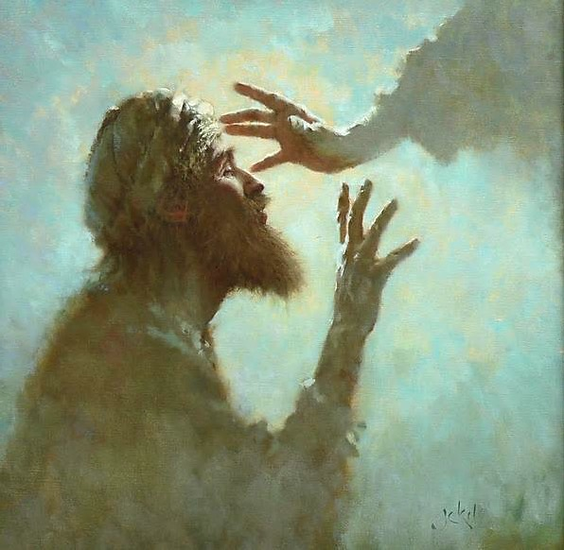

“See, we are going up to Jerusalem,
and everything that is written by the prophets
concerning the Son of Man will be accomplished” …
…But they understood none of these things:
and this saying was hidden from them,
and they did not grasp what was said.

St Luke 18:31, 34

Crèche and Sunday school are being held in Parsonage Hall next door.
Parents are welcome to bring their children there before the service begins.
The children will be brought back by their teachers and carers
after the sermon but in time to see the baptism.

- 13 -

The Blessing
The priest prays,
The peace of God,
which passes all understanding,
keep your hearts and minds
in the knowledge and love of God,
and of his Son Jesus Christ our Lord;
and the blessing of God almighty,
the Father, the Son, and the Holy Spirit,
be among you and remain with you always.
All Amen.

Announcements

Closing Hymn: 386 Be thou my vision, O Lord of my heart

A minister says
Go in peace to love and serve the Lord.
All In the name of Christ. Amen.

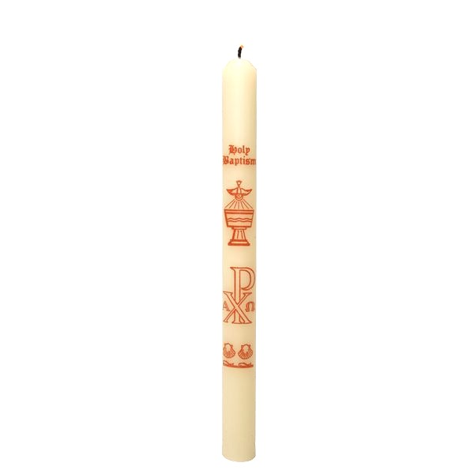

A warm welcome to you this day!
If you can, please stay for tea or coffee in the church hall after the service.
- 12 -

The Communion

The priest prays,
Draw near with faith. Receive the body of our Lord Jesus Christ which he gave for you, and his blood which he shed for you. Eat and drink in remembrance that he died for you, and feed on him in your hearts by faith with thanksgiving.

The priest and people receive communion.

Authorized words of distribution are used and the communicant replies
Amen.

Baptized persons who are communicant members of other Churches which subscribe to the doctrine of the Holy Trinity and are in good standing in their own Church are welcome to Communion. Come forward with faith, hope, and love, discerning the Lord’s body.

Those who do not wish to receive Communion are welcome to come forward for a blessing – you may indicate by crossing your arms over your chest at the altar rail.

Post Communion Hymn: 279 And now, O Father, mindful of the love

Prayer after Communion

[Silence is kept]

All Almighty God,
we thank you for feeding us
with the body and blood of your Son Jesus Christ.
Through him we offer you our souls and bodies
to be a living sacrifice.
Send us out
in the power of your Spirit
to live and work
to your praise and glory.

Amen.

The Sunday called Quinquagesima
Service setting: Hopper in D

Opening Hymn: 527 New songs of celebration render

In the name of the Father, and of the Son, and of the Holy Spirit.
All Amen.

The priest greets the people
The Lord be with you
All and also with you.

All Almighty God,
to whom all hearts are open, all desires known,
and from whom no secrets are hidden:
cleanse the thoughts of our hearts
by the inspiration of your Holy Spirit,
that we may perfectly love you,
and worthily magnify your holy name;
through Christ our Lord.
Amen.

Summary of the Law
Our Lord Jesus Christ said:
The first commandment is this:
‘Hear, O Israel, the Lord our God is the only Lord;
You shall love the Lord your God with all your heart,
with all your soul, with all your mind,
and with all your strength.’

The second is this:
‘Love your neighbour as yourself.’
There is no other commandment greater than these.
On these two commandments hang all the law and the prophets.

All Amen. Lord, have mercy.
- 2 -

Kyrie

Cantor All
Lord, have mer – cy Lord, have mer – cy

Cantor All
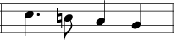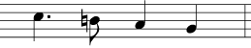
Christ, have mer –– cy Christ, have mer –– cy

Cantor All
Lord, have mer ––– cy Lord, have mer –– cy

The Collect: O LORD, who has taught us that all our doings without love are worth nothing: Send your Holy Spirit, and pour into our hearts that most excellent gift of love, the very bond of peace and of all virtues, without which whosoever lives is counted dead before you: Grant this for your only Son Jesus Christ's sake. Amen.

Old Testament Reading: Genesis 9:8-17
Then God said to Noah and to his sons with him, “Behold, I establish my covenant with you and your offspring after you, and with every living creature that is with you, the birds, the livestock, and every beast of the earth with you, as many as came out of the ark; it is for every beast of the earth. I establish my covenant with you, that never again shall all flesh be cut off by the waters of the flood, and never again shall there be a flood to destroy the earth.” And God said, “This is the sign of the covenant that I make between me and you and every living creature that is with you, for all future generations: I have set my bow in the cloud, and it shall be a sign of the covenant between me and the earth. When I bring clouds over the earth and the bow is seen in the clouds, I will remember my covenant that is between me and you and every living creature of all flesh. And the waters shall never again become a flood to destroy all flesh. When the bow is in the clouds, I will see it and remember the everlasting covenant between God and every living creature of all flesh that is on the earth.” God said to Noah, “This is the sign of the covenant that I have established between me and all flesh that is on the earth.”

This is the word of the Lord. Thanks be to God.
- 11 -

Agnus Dei

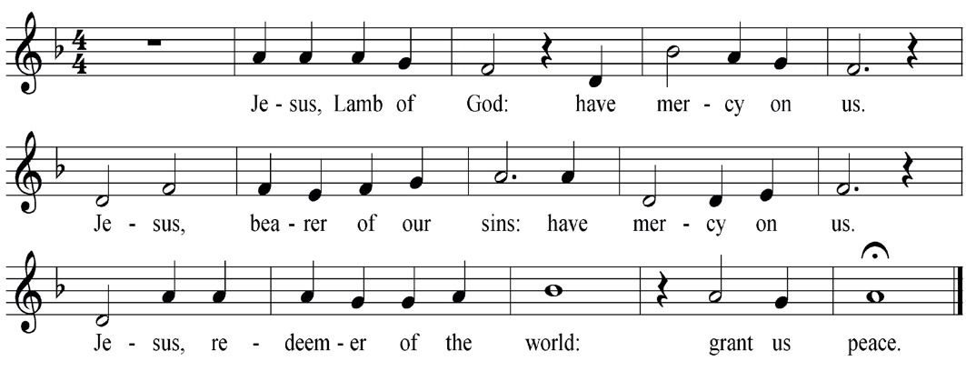

Prayer of Humble Access

All We do not presume to come to this your table,
O merciful Lord, trusting in our own righteousness,
but in your manifold and great mercies.
We are not worthy
so much as to gather up the crumbs under your table.
But you are the same Lord
whose nature is always to have mercy.
Grant us therefore, gracious Lord,
so to eat the flesh of your dear Son Jesus Christ
and to drink his blood,
that our sinful bodies may be made clean by his body
and our souls washed through his most precious blood,
and that we may evermore dwell in him,
and he in us.
Amen.

- 10 -
(we kneel)
All glory be to you, our heavenly Father, who, in your tender mercy,
gave your only Son our Saviour Jesus Christ
to suffer death upon the cross for our redemption;
who made there by his one oblation of himself once offered
a full, perfect and sufficient sacrifice, oblation and satisfaction
for the sins of the whole world;
he instituted, and in his holy gospel commanded us to continue,
a perpetual memory of his precious death until he comes again.

Hear us, merciful Father, we humbly pray,
and grant that, by the power of your Holy Spirit,
we receiving these gifts of your creation, this bread and this wine,
according to your Son our Saviour Jesus Christ’s holy institution,
in remembrance of his death and passion,
may be partakers of his most blessed body and blood;

who, in the same night that he was betrayed, took bread and gave you thanks;
he broke it and gave it to his disciples, saying:

Take, eat; this is my body which is given for you;
do this in remembrance of me.

In the same way, after supper he took the cup and gave you thanks;
he gave it to them, saying:

Drink this, all of you; this is my blood of the new covenant,
which is shed for you and for many for the forgiveness of sins.
Do this, as often as you drink it, in remembrance of me.
All Amen

[Silence is kept]

Let us pray with confidence as our Saviour has taught us

All Our Father, who art in heaven, hallowed be thy name;
thy kingdom come; thy will be done;
on earth as it is in heaven.
Give us this day our daily bread.
And forgive us our trespasses,
as we forgive those who trespass against us.
And lead us not into temptation; but deliver us from evil.
For thine is the kingdom, the power and the glory,
for ever and ever.
Amen.
- 3 -
Psalm 77:11-end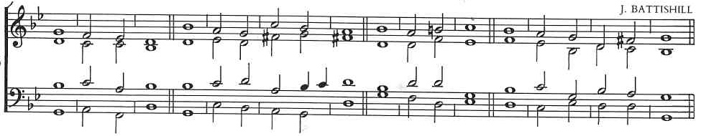
11 I will remember the ’ works of the ’ Lord : and call to mind thy ’ wonders of ‘old ’ time.
12 I will think also of ’ all thy ’ works : and my talking shall ’ be of ’ thy ’ doings.
13 Thy way O ’ God is ’ holy : who is so ’ great a ’ God as ’ our God?
14 Thou art the God that ’ doeth ’ wonders : and hast declared thy ’ power a’mong the ’
people.
15 Thou hast mightily de’livered thy ’ people : even the ’ sons of ’ Jacob and ’ Joseph.
16 The waters saw thee O God, the waters saw thee and ’ were a’fraid : the ’ depths ’
also were ’ troubled.
17 The clouds poured out water the ’ air ’ thundered : and thine ’ arrows ’ went a’broad.
18 The voice of thy thunder was heard ’ round a’bout : the lightnings shone upon the
ground, the earth was ’ moved and ’ shook with’al.
19 Thy way is in the sea, and thy paths in the ’ great ’ waters : and thy ’ footsteps ’ are
not ’ known.
20 Thou leddest thy ’ people like ’ sheep : by the ’ hand of ’ Moses and ’ Aaron.

Glory be to the Father ’ and to • the ’ Son : and ’ to the ’ Holy ’ Ghost;
As it was in the beginning is ’ now and • ever ’ shall be : world without ’ end. A ’ — ’ men.

Alleluia (3x) I am the Light of the world ’ says the ’ Lord.
Whoever follows me will never walk in darkness but will ’ have the • light of ’ life. Alleluia (3x)

The Gospel: St Luke 18:31-end
Before the Gospel we sing: Glory to you, O Lord

“Taking the twelve, he said to them, “See, we are going up to Jerusalem, and everything that is written about the Son of Man by the prophets will be accomplished. For he will
be delivered over to the Gentiles and will be mocked and shamefully treated and spit upon. And after flogging him, they will kill him, and on the third day he will rise.” But they understood none of these things. This saying was hidden from them, and they did not grasp what was said.
As he drew near to Jericho, a blind man was sitting by the roadside begging. And hearing a crowd going by, he inquired what this meant. They told him, “Jesus of Nazareth is passing by.” And he cried out, “Jesus, Son of David, have mercy on me!” And those who were in front rebuked him, telling him to be silent. But he cried out all the more, “Son of David, have mercy on me!” And Jesus stopped and commanded him to be brought to him. And when he came near, he asked him, “What do you want me to do for you?” He said, “Lord, let me recover my sight.” And Jesus said to him, “Recover your sight; your faith has made you well.” And immediately he recovered his sight and followed him, glorifying God. And all the people, when they saw it, gave praise to God.
After the Gospel we sing: Praise to you, O Christ
- 4 -

Sermon

Hymn: 581 (vs 1-3,6) Take my life and let it be [Tune: Vienna #489]

Holy Baptism of Tijmen Matteo Sleurink Riet

The child is presented to the congregation by his parents in these or similar words

Brothers and sisters in Christ we welcome today this child into the Church.
I invite his parents to present him.

Parents We present Tijmen Matteo to be baptized.

The priest addresses the whole congregation
Faith is the gift of God to his people.
In baptism the Lord is adding to our number those whom he is calling.
People of God, will you welcome this child
and uphold him in his new life in Christ?
All With the help of God, we will.

The priest then says to the parents
Parents, the Church receives this child with joy.
Today we are trusting God for his growth in faith.
Will you pray for him,
draw him by your example into the community of faith
and walk with him in the way of Christ?
Parents With the help of God, we will.

In baptism this child begins his journey in faith.
You speak for him today.
Will you care for him,
and help him to take his place
within the life and worship of Christ’s Church?
Parents With the help of God, we will.

The Decision

The priest addresses the child through his parents
In baptism, God calls us out of darkness into his marvellous light.
To follow Christ means dying to sin and rising to new life with him.
Therefore I ask:

Do you reject the devil and all rebellion against God?
I reject them.

Do you renounce the deceit and corruption of evil?
I renounce them.

Do you repent of the sins that separate us from God and neighbour?
I repent of them.

Do you turn to Christ as Saviour?
I turn to Christ.
- 9 -

The Peace (we stand):

The peace of the Lord be always with you.

All and also with you.

We offer one another a sign of peace.

Offertory Hymn: 516 Love divine, all loves excelling [Tune 2: Blainwern]

Your offerings will be received during this hymn.
The basket is to support the regular work of this chaplaincy.
The red bag is for charitable giving. Today we support OMDUW.
OMDUW helps people in the city of Utrecht, such as the homeless.

Eucharistic Prayer

The Lord be with you.
All And also with you.

Lift up your hearts.
All We lift them to the Lord.

Let us give thanks to the Lord our God.
All It is right to give thanks and praise.

It is indeed right, …
…for ever praising you and singing:

Sanctus and Benedictus
Ho----ly, ho----ly, ho ---- ly Lord,

God of power and might, hea - ven and earth are

full of your glo --- ry. Ho --- san --- na in the high – est!

Bless - ed is he who comes in the

name of the Lord, Ho --- san --- na in the high – est!
- 8 -

The Welcome

There is one Lord, one faith, one baptism:
Tijmen Matteo, by one Spirit we are all baptized into one body.

All We welcome you into the fellowship of faith;
we are children of the same heavenly Father;
we welcome you.

The Intercessions (we kneel)

The intercessor prays: Lord, in your mercy
We respond: Hear our prayer

And at the end: Merciful Father
We all say: accept these prayers
for the sake of your Son
our Saviour Jesus Christ. Amen.

Confession and Absolution

Priest God so loved the world that he gave his only Son Jesus Christ to save us from our sins, to be our advocate in heaven, and to bring us to eternal life.

Let us confess our sins in penitence and faith, firmly resolved to keep God’s
commandments and to live in love and peace with all.

We pray after a moment of silence

All Almighty God, our heavenly Father,
we have sinned against you and against our neighbour
in thought and word and deed,
through negligence, through weakness,
through our own deliberate fault.

We are truly sorry and repent of all our sins.

For the sake of your Son Jesus Christ, who died for us,
forgive us all that is past
and grant that we may serve you in newness of life
to the glory of your name. Amen.

Priest Almighty God, who forgives all who truly repent, have mercy upon you, pardon and deliver you from all your sins, confirm and strengthen you in all goodness, and keep you in life eternal; through Jesus Christ our Lord.
All Amen.
- 5 -

Do you submit to Christ as Lord?
I submit to Christ.

Do you come to Christ, the way, the truth and the life?
I come to Christ.

Priest May almighty God deliver you from the powers of darkness,
restore in you the image of his glory,
and lead you in the light and obedience of Christ.
All Amen.

Prayer over the Water
The priest prays,
Praise God who made heaven and earth,
All who keeps his promise for ever.

Let us give thanks to the Lord our God.
All It is right to give thanks and praise.

Let us pray.
We thank you, almighty God, for the gift of water to sustain,
refresh and cleanse all life. Over water the Holy Spirit moved
in the beginning of creation.
Through water you led the children of Israel
from slavery in Egypt to freedom in the Promised Land.
In water your Son Jesus received the baptism of John
and was anointed by the Holy Spirit as the Messiah, the Christ,
to lead us from the death of sin to newness of life.
We thank you, Father, for the water of baptism.
In it we are buried with Christ in his death.
By it we share in his resurrection.
Through it we are reborn by the Holy Spirit.
Therefore, in joyful obedience to your Son,
we baptize into his fellowship those who come to him in faith.
Now sanctify this water that, by the power of your Holy Spirit, he may be cleansed from sin and born again. Renewed in your image, may he walk by the light of faith and continue for ever in the risen life of Jesus Christ our Lord;
to whom with you and the Holy Spirit be all honour and glory,
now and for ever.
All Amen.
- 6 -

Profession of Faith
The priest addresses the congregation

Brothers and sisters, I ask you to profess together
the faith of the Church.

Do you believe and trust in God the Father?
All I believe in God, the Father almighty,
creator of heaven and earth.

Do you believe and trust in his Son Jesus Christ?
All I believe in Jesus Christ, his only Son, our Lord,
who was conceived by the Holy Spirit,
born of the Virgin Mary,
suffered under Pontius Pilate,
was crucified, died, and was buried;
he descended to the dead.
On the third day he rose again;
he ascended into heaven,
he is seated at the right hand of the Father,
and he will come to judge the living and the dead.

Do you believe and trust in the Holy Spirit?
All I believe in the Holy Spirit,
the holy catholic Church,
the communion of saints,
the forgiveness of sins,
the resurrection of the body,
and the life everlasting.
Amen.

The Baptism
The priest pours water on the child, saying
Tijmen Matteo I baptize you in the name of the Father, and of the Son,
and of the Holy Spirit.
All Amen.

The Sign of the Cross
The priest makes the sign of the cross on the forehead of the child, saying
Christ claims you for his own. Receive the sign of his cross.
Do not be ashamed to confess the faith of Christ crucified.
- 7 -

All Fight valiantly as a disciple of Christ
against sin, the world and the devil,
and remain faithful to Christ to the end of your life.

The priest says
May God, who has received you by baptism into his Church,
pour upon you the riches of his grace,
that within the company of Christ’s pilgrim people
you may daily be renewed by his anointing Spirit,
and come to the inheritance of the saints in glory.
All Amen.

Giving of a Lighted Candle
God has delivered us from the dominion of darkness
and has given us a place with the saints in light.
You have received the light of Christ;
walk in this light all the days of your life.
All Shine as a light in the world
to the glory of God the Father.

After the child has been baptized, the priest and family may return from the font.

Commission
Where the newly baptized are unable to answer for themselves, a minister addresses the congregation and parents, using these or similar words

As he grows up, he will need the help and encouragement of the Christian community, so that he may learn to know God in public worship and private prayer, follow Jesus Christ in the life of faith, serve his neighbour after the example of Christ, and in due course come to confirmation.
As part of the Church of Christ, we all have a duty to support him by prayer, example and teaching. As his parents, you have the prime responsibility for guiding and helping him in his early years. This is a demanding task for which you will need the help and grace of God.
Therefore let us now pray for grace in guiding this child in the way of faith.
Let us pray:
Faithful and loving God, bless those who care for this child
and grant him your gifts of love, wisdom and faith.
Pour upon him your healing and reconciling love, and protect his home
from all evil. Fill him with the light of your presence and establish him in the joy of your kingdom, through Jesus Christ our Lord.
All Amen.

